**LAB # 1**

Objectives

* *Introduction to UML.*
* *Use case diagrams: discovering actors and use cases.*

1.Airport check-in and security screening business model

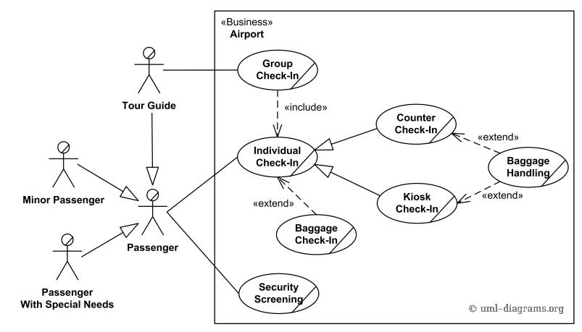

2.Restaurant business model

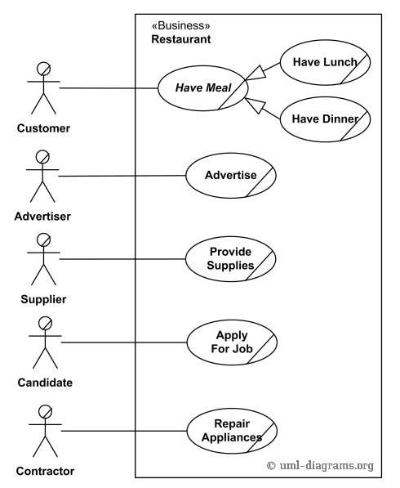

3.Ticket vending machine

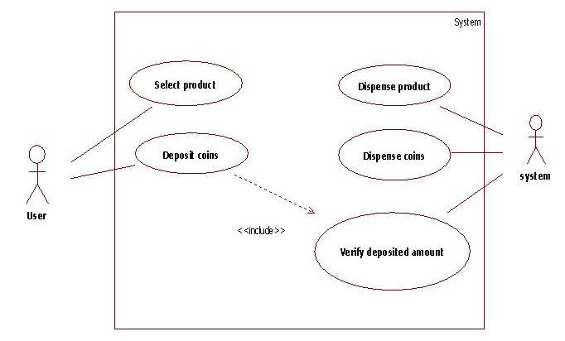

4.Bank ATM UML use case diagrams examples

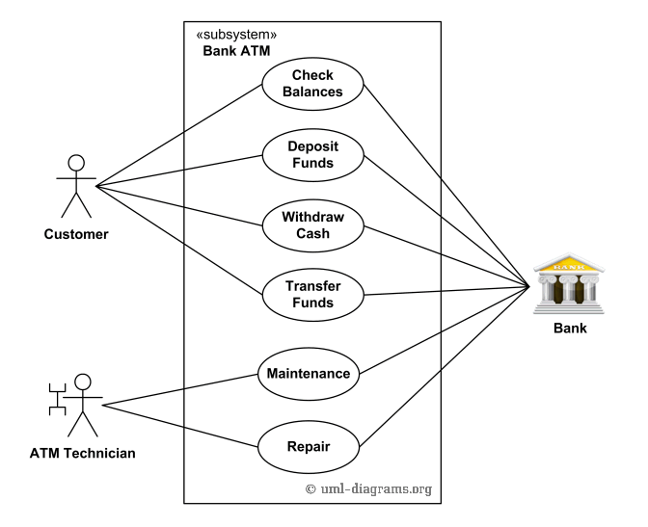

5.Point of sales (POS) terminal

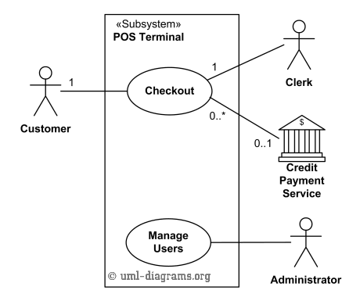

6.e-Library online public access catalog (OPAC)

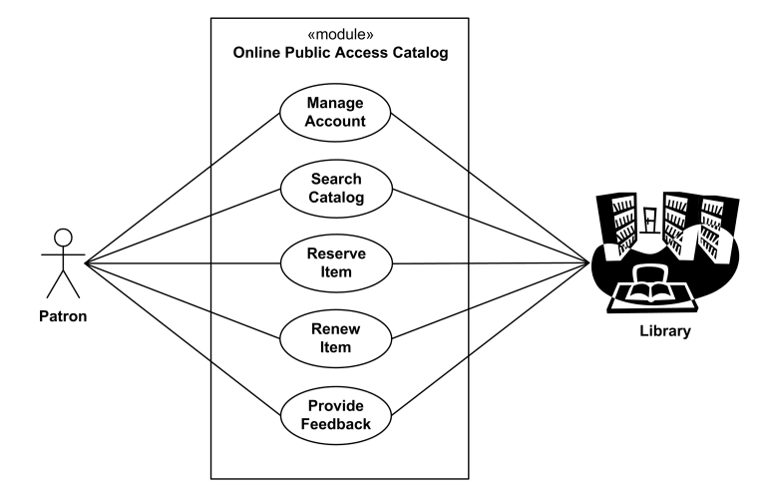

7.Online shopping use case diagrams

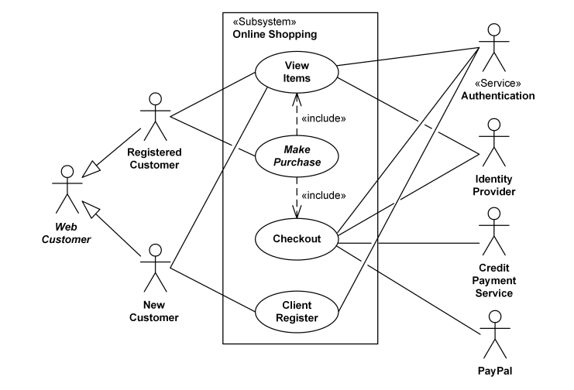

8.Website administration

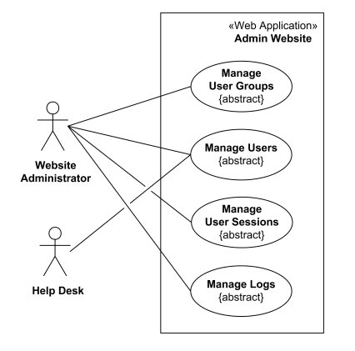

9.Hospital Management

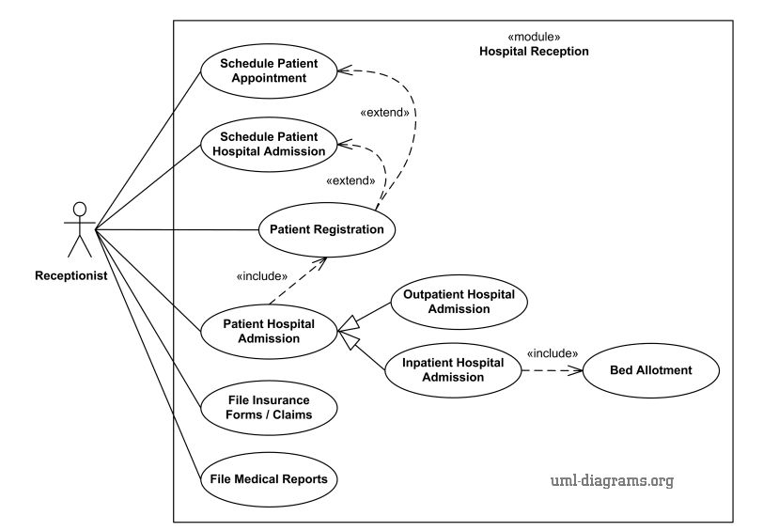

10.Radiology diagnostic reporting UML use case diagram

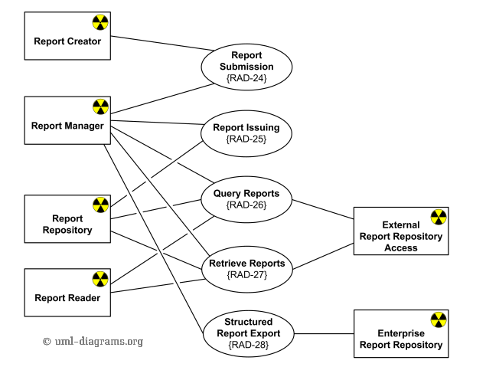

1. Design a UML diagram for a centralized hotel reservation system which is working online, hotel desktop application and a customized application for travel agents.

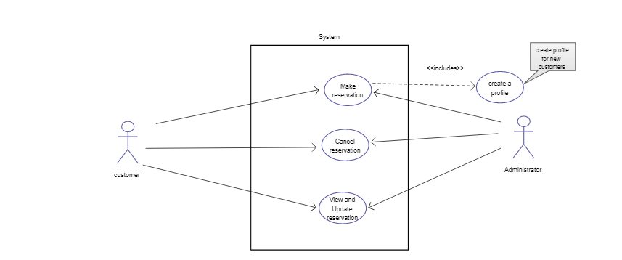

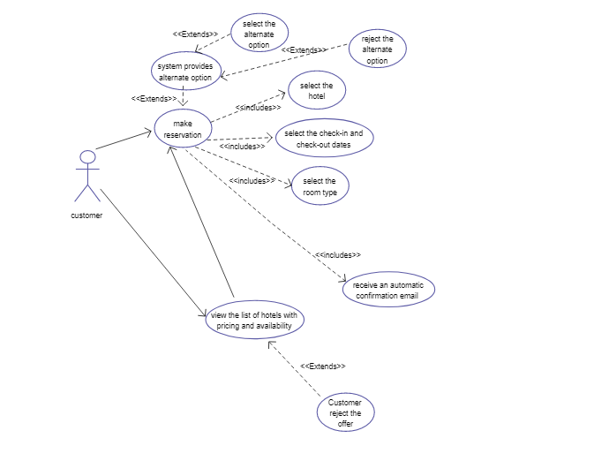

**LAB # 2**

**Exercise**

1. Design a class diagram of an *Order System* of an application. So it describes a particular aspect of the entire application. Draw class diagram considering all the points mentioned below:

* First of all *Order* and *Customer* are identified as the two elements of the system and they have a *one to many* relationship because a customer can have multiple orders.
* We would keep *Order* class is an abstract class and it has two concrete classes (inheritance relationship) *SpecialOrder* and *NormalOrder*.
* The two inherited classes have all the properties as the *Order* class. In addition they have additional functions like *dispatch ()* and *receive ()*.

**ANSWER**

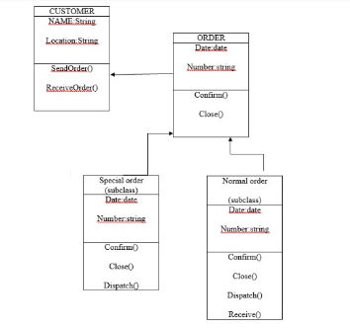

1. Design a class diagram for the transactions of bank (Considering only checking balance, withdraw cash and deposit cash for the sake of simplicity.

|  |
| --- |
| **TRANSACIONS** |
| +Transaction id |
| +withdraw cash()  +deposit cash()  +check balance() |